

Services

Expertise

**EN**

**FR**

Get in touch

Company



In order to increase their engineering capabilities, we build quality solutions and software for technology companies

video

video

**View all >**

**Who We Are?**

HumanOne is your specialized partner in the development of software solutions and digitalization by combining the best engineering talent with a total commitment to meeting the unique expectations of each of its clients.

We offer to update and innovate the management processes used by your company in order to optimize efficiency and reduce costs.

HumanOne favors a horizontal, agile, flexible and transparent organization. We deploy all of our energies, which makes us a reliable and proven software engineering provider,

Get to know us >

**Our Promise…**

We bring to our clients the best engineering talent, a deep knowledge of each sector in which we operate, and an unwavering dedication to satisfying each of our clients' requests

No matter how complex your project is, we deploy all of our resources to deliver the most technological and efficient solutions and softwares. We offer digital workflows that create exceptional experiences and maximize productivity.

Our added value is manifested in the combination of solid and restricted human relationships with the upmost technology in our multiple missions.

We attach great importance to the ethics and values of our profession such as integrity, confidentiality, transparency and honesty of our proposals.

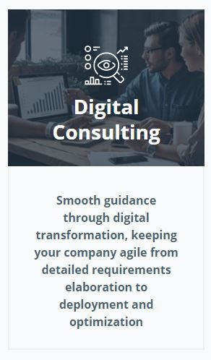

**Our services**

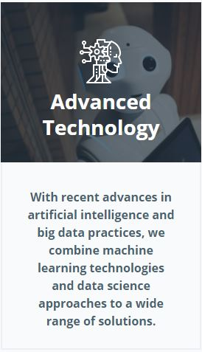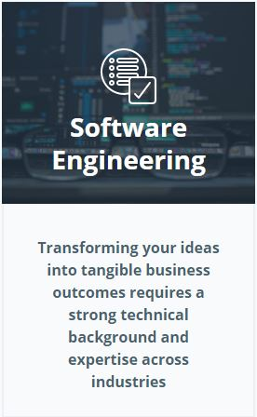

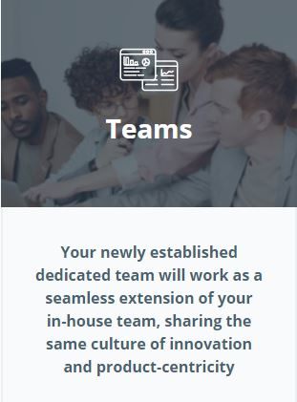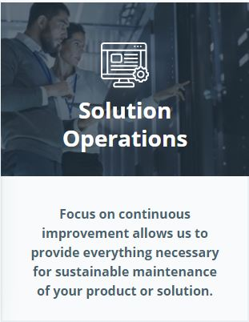

**Our Expertises**

Plateform Development



With our platform engineering expertise and your product vision, we can create a thriving ecosystem of integrated solutions and service providers so you can tap into economies of scale without being anchored by production costs.

Plateform Development

Cloud Software Development services

With our platform engineering expertise and your product vision, we can create a thriving ecosystem of integrated solutions and service providers so you can tap into economies of scale without being anchored by production costs.

With our platform engineering expertise and your product vision, we can create a thriving ecosystem of integrated solutions and service providers so you can tap into economies of scale without being anchored by production costs.



Machine Learning

& Artificiel Intelligence

DevOps

Cloud Consulting services

With our platform engineering expertise and your product vision, we can create a thriving ecosystem of integrated solutions and service providers so you can tap into economies of scale without being anchored by production costs.

With our platform engineering expertise and your product vision, we can create a thriving ecosystem of integrated solutions and service providers so you can tap into economies of scale without being anchored by production costs.

With our platform engineering expertise and your product vision, we can create a thriving ecosystem of integrated solutions and service providers so you can tap into economies of scale without being anchored by production costs.



Location Based Services

Internet of Things Development Services

UI/UX Design Services

With our platform engineering expertise and your product vision, we can create a thriving ecosystem of integrated solutions and service providers so you can tap into economies of scale without being anchored by production costs.

With our platform engineering expertise and your product vision, we can create a thriving ecosystem of integrated solutions and service providers so you can tap into economies of scale without being anchored by production costs.

With our platform engineering expertise and your product vision, we can create a thriving ecosystem of integrated solutions and service providers so you can tap into economies of scale without being anchored by production costs.



Cybersecurity Services

Blockchain Development Services

With our platform engineering expertise and your product vision, we can create a thriving ecosystem of integrated solutions and service providers so you can tap into economies of scale without being anchored by production costs.

With our platform engineering expertise and your product vision, we can create a thriving ecosystem of integrated solutions and service providers so you can tap into economies of scale without being anchored by production costs.



## Project setup

As soon as HumanOne receives your project, we give you instant access to all of our technological skills supported by our ready-to-use IT infrastructure and our most proven software engineering processes.

## 

## What's new

Article 8

Article 7

Article 6

Article 5

Article 4

Article 3

Article 2

Article 1

**View all >**

